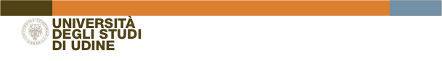

ERASMUS+ STUDIO 

Mobility Programme a.a.2024/2025

ATTENDANCE CERTIFICATE

ATTESTATO DI FREQUENZA ERASMUS
To be filled in at the end of the study period

NB (for the student): da restituire all’Ufficio Mobilità e Relazioni Internazionali - UNIUD
entro 10 giorni dal rientro dalla mobilità

This is to certify that the student ____________________________________________
(full name)
coming from the University of Udine I UDINE01

field of study__________________________________________________________________

has completed the study period within the ERASMUS+ STUDIO Programme at the UNIVERSITY of________________________________________________

ERASMUS CODE NUMBER_________________________________________________________

during the Erasmus year 2024/2025
from (dd/mm/yy)________________________________________________

to (dd/mm/yy) ________________________________________________________________

total months____________________________________________________

for the Host Institution

Signature ___________________________________________

Institutional position___________________

Date ________________

seal

